**SUPPLEMENTARY MATERIALS**

**Mathematical Analysis of Robustness of Oscillations in Models of the Mammalian Circadian Clock**

B. Heidebrecht, J. Chen & J.J. Tyson

Table of Contents

Table S1. Definitions of the dynamical variables in the models. 2

Table S2. Definitions of the kinetic constants in the models. 2

Table S3. Parameter values used in the model simulations in Figure S1 and Figure 3. 3

Table S4. Parameter values used in the model simulations in Figure 4 and Figure S5. 3

Table S5. Parameter values used in the SNF model comparisons in Figure S2. 4

Figures S1-S5 5

Model naming convention 10

Non-dimensionalization of the modified Kim-Forger equations 10

Estimation of the scaling factor *P*\*. 11

Estimation of a physically realistic range of *K*dvalues. 12

Deriving the rate laws for *PER* transcription 13

Simulation Methods 16

Supplementary references 18

# Table S1. Definitions of the dynamical variables in the models.

|  |  |
| --- | --- |
| **Variable** | **Physical Meaning** |
| *M* | *PER* mRNA |
| *Pi* | Cytoplasmic PER species |
| *P* | Nuclear PER |
| *A* | Nuclear BMAL |
| *R* | Nuclear ROR |
| *V* | Nuclear REV-ERB |

# Table S2. Definitions of the kinetic constants in the models.

|  |  |
| --- | --- |
| **Parameter** | **Definition** |
| *K*d | Dissociation constant of the PER:BMAL complex |
| *K*A | Dissociation constant of the BMAL:Ebox complex |
| *K*m | Michaelis constant for the degradation of nuclear PER |
| *A*T | Total BMAL concentration (bound + unbound) |
| *A*MAX | Maximal rate of synthesis of BMAL |
| *V*MAX | Maximal rate of synthesis of REV-ERB |
| *R*MAX | Maximal rate of synthesis of ROR |
| *β* | Rate constant for degradation of nuclear PER |
| *γ* | Rate constant for synthesis of BMAL |
| *δ* | Rate constant for degradation of BMAL, REV-ERB and ROR |
| *ε* | Basal rate of synthesis of BMAL |
| *φ* | Fold change in *PER* transcription rate (gene dosage) |

# Table S3. Parameter values used in the model simulations in Figure 3 and Figure S1.

|  |  |  |  |  |  |  |
| --- | --- | --- | --- | --- | --- | --- |
| **Param** | **SNF**  **(0LN)** | | **SNF**  **(0MN)** | **SNF**  **(1MN)** | **SNF**  **(2LN)** | **SNF**  **(2MN)** |
| *K*d |  | variable | | | | |
| *K*A |  | |  | 0.01 | 0.01 | 0.01 |
| *K*m |  | | 0.01 | 0.01 |  | 0.01 |
| *A*T |  | variable | | | | |
| *β* |  | | 60 | 60 |  | 60 |
| *φ* | 1 | | 1 | 1 | 1 | 1 |

# Table S4. Parameter values used in the model simulations in Figures 4, 5 and Figures S3-S5.

|  |  |  |  |  |  |  |  |
| --- | --- | --- | --- | --- | --- | --- | --- |
| **Param** | **SNF**  **(0L3)** | **NNF**  **(0L3)** | **PNF**  **(0L3)** | **SNF**  **(2M8)** | **NNF**  **(2M8)** | **PNF**  **(2M8)** | **PNNF**  **(2M8)** |
| *K*d | 10−5 | 10−5 | 10−5 | 0.1 | 0.1 | 0.1 | 0.1 |
| *K*A |  |  |  | 0.01 | 0.01 | 0.01 | 0.01 |
| *K*m |  |  |  | 0.01 | 0.01 | 0.01 | 0.01 |
| *A*T | variable |  |  | variable |  |  |  |
| *A*MAX |  | variable | |  | variable | | |
| *V*MAX |  |  |  |  | 1 |  | 1 |
| *R*MAX |  |  |  |  |  | 0.1 | 0.1 |
| *β* |  |  |  | 60 | 60 | 60 | 60 |
| *γ* |  | 0.0043 | 0.0395 |  |  |  |  |
| *δ* |  | 0.2 | 0.2 |  | 0.2 | 0.2 | 0.2 |
| *ε* |  |  |  |  |  |  | 0.01 |
| *φ* | variable | | | | | | |

# Table S5. Parameter values used in the SNF model comparisons in Figure S2.

|  |  |  |  |  |
| --- | --- | --- | --- | --- |
| **Param** | **SNF**  **(0LN)** | **SNF**  **(0MN)** | **SNF**  **(2LN)** | **SNF**  **(2MN)** |
| *K*d | 10−4 | 10−4 | 10−4 | 10−4 |
| *K*A |  |  | 0.01 | 0.01 |
| *K*m |  | 0.01 |  | 0.01 |
| *A*T | variable | | | |
| *β* |  | 60 |  | 60 |
| *φ* | variable | | | |

# Figures S1-S5

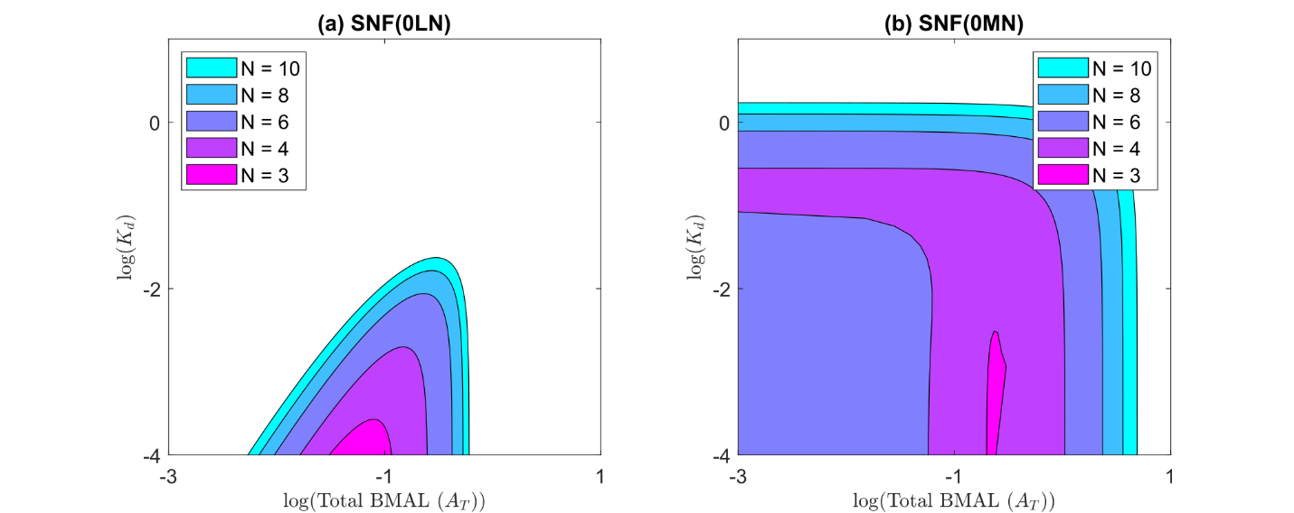

**Figure S1.** Two parameter bifurcation curves with respect to parameters *K*d and *A*T for different numbers of reactions steps, N, **(a)** for the SNF(0LN) model (identical to Figure 3a in the main text), and **(b)** for the SNF(0MN) model. Notice that, for SNF(0MN), the maximum value of *K*d permissible for oscillations is ~1, but these oscillations persist as *A*T → 0, which is biochemically impossible. The problem lies in the assumption that the rate of *PER* mRNA transcription is proportional to *A*free/*A*T. We correct the problem by introducing alternative expressions for this probability (rate laws 1 and 2). Parameter values are given in Table S3.

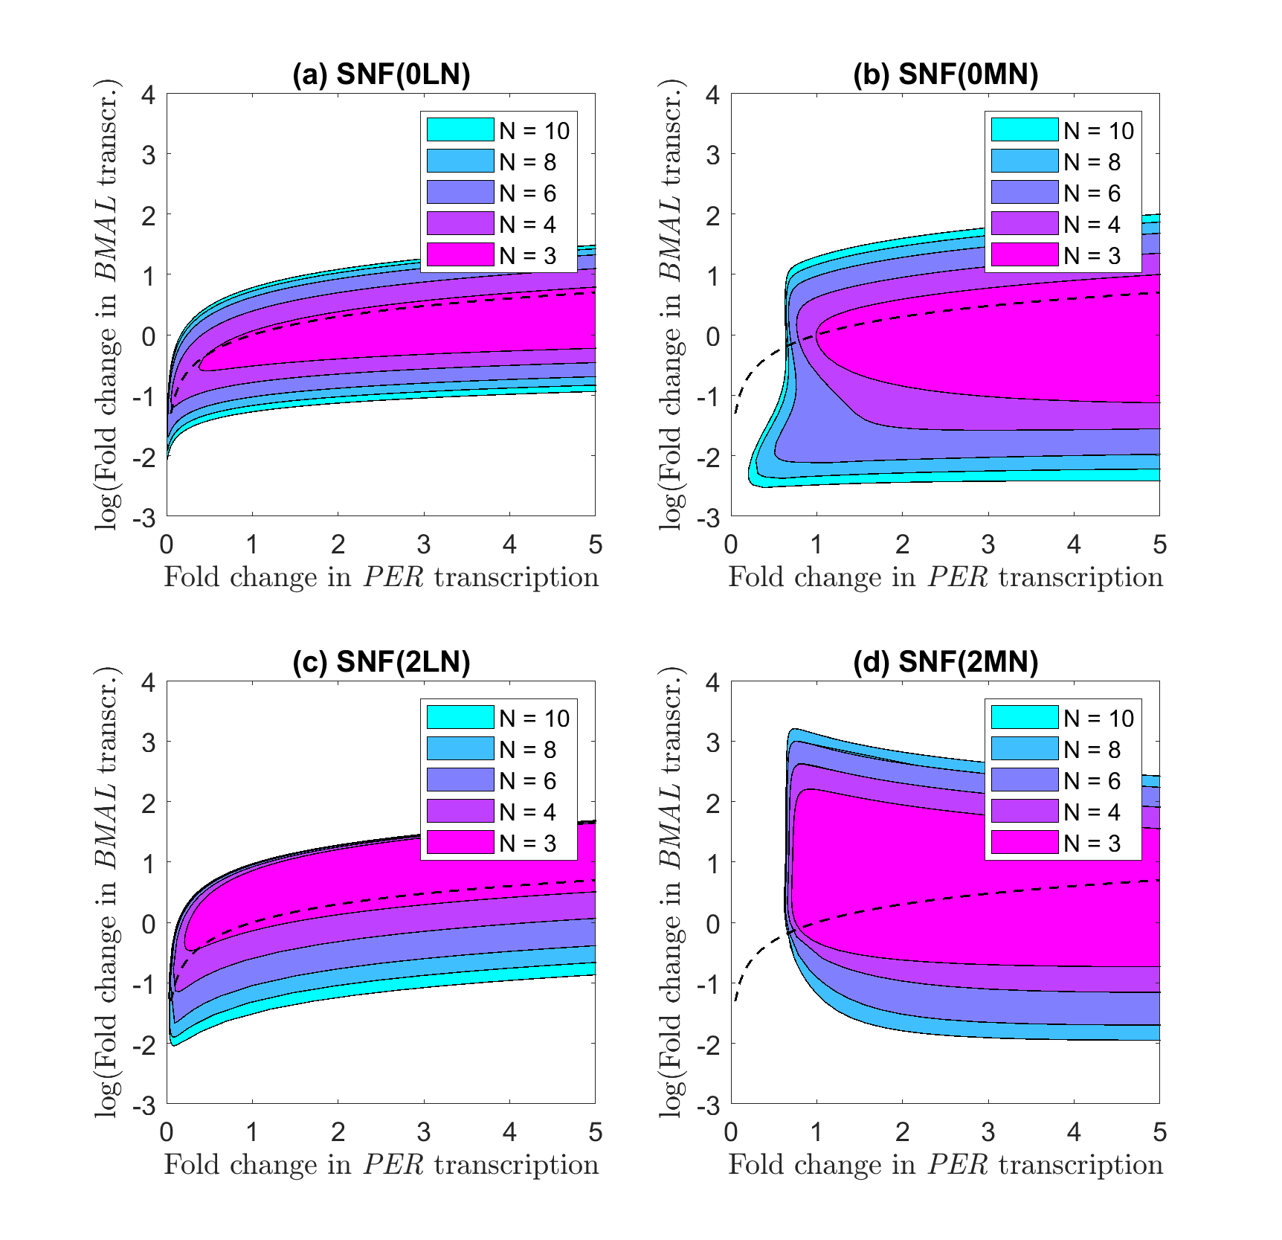

**Figure S2.** Two-parameter bifurcation diagrams, with respect to fold changes in *BMAL* transcription (*A*T) and *PER* transcription (*φ*). **(a)** SNF(0LN), **(b)** SNF(0MN), **(c)** SNF(2LN), and **(d)** SNF(2MN) models. Dashed lines in all panels show the line of identity on linear scale, i.e., *x* = *y*. For models with a linear rate of degradation of nuclear PER (0LN, 2LN), there is a distinct positive correlation between expression levels of BMAL and PER, which is reflective of the ‘stoichiometric balance’ between BMAL and PER molecules observed by Kim & Forger as a requirement for oscillations in their model, SNF(0LN). For Michaelis-Menten degradation of nuclear PER, the correlation is weak (panel b) or non-existent (panel d). The parameter values used in these calculations are provided in Table S5; in particular, *K*d = 10−4 to allow oscillations in all cases.



**Figure S3.** Two-parameter bifurcation curves with respect to fold changes in *PER* transcription rate (*φ*) and *BMAL* transcription rate (*A*MAX) for the NNF(2M8) model for representative values of **(a)** the degradation rate constant *δ* and **(b)** the feedback loop length N. Parameter values other than those shown in the plots are given in Table S4.

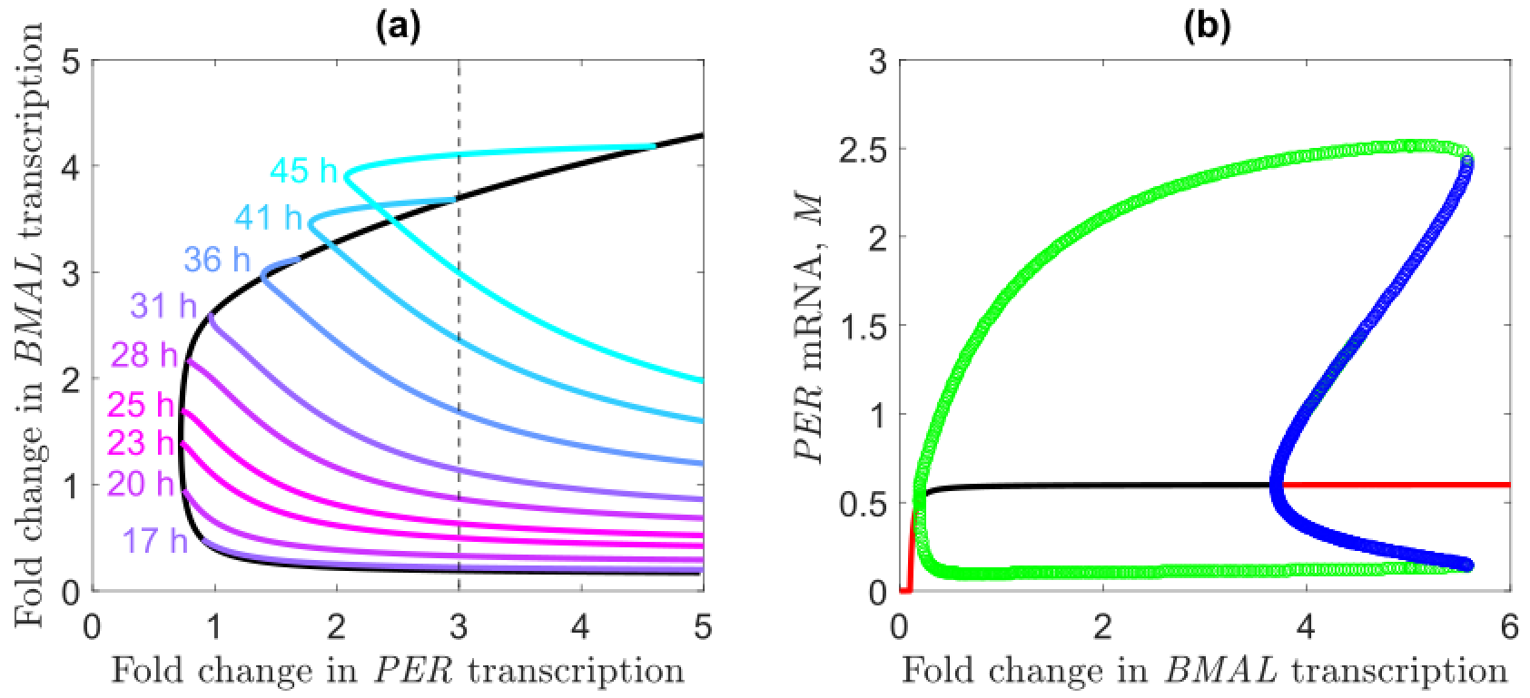

**Figure S4.** One- and two-parameter bifurcation curves for the PNF(2M8) model. **(a)** Oscillatory region on a two-parameter plane (*A*MAX versus *φ*). Black line, locus of Hopf bifurcation points; colored lines, loci of oscillations of fixed period (17-45 h). Notice that oscillations extend outside the area bounded by Hopf bifurcations, which is indicative of sub-critical Hopf bifurcations. **(b)** One-parameter bifurcation curve with respect to *A*MAX for $φ=3$ (dashed line in panel a). Red lines, stable steady states; black line, unstable steady states; green lines, amplitude of stable limit cycles; blue lines, amplitude of unstable limit cycles. The Hopf bifurcation at *A*MAX ≈ 3.7 is sub-critical, i.e., the bifurcating limit cycles are unstable. Parameter values other than those shown in the plots are given in Table S4.

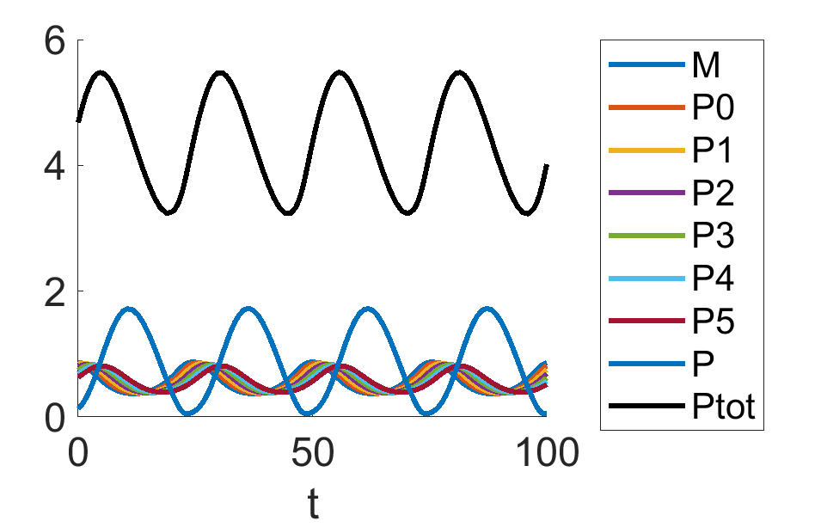

**Figure S5.** Simulation results of SNF(2M8) model. *P*tot = *P*0+*P*1+*P*2+*P*3+*P*4+*P*5+*P*. All variables, including time *t*, are dimensionless. *A*T = 0.1, *φ* = 1, and the remaining parameters follow the case SNF(2M8) in Table S4.

# Model naming convention

Our modified Kim-Forger models can have four different feedback topologies, three different *PER* transcription rate laws, two different PER degradation rate laws, and Nnumber of steps in the core PER-BMAL feedback loop. So, it is useful to introduce a standard naming convention, M(TDN), for each of these combinatorial possibilities: M = model name (SNF, NNF, etc.), T = transcription rate law (0, 1, 2, according to Eq. 19 in the main text), and D = degradation rate law (L for linear, M for Michaelis-Menten). For example, the original Kim-Forger SNF model is denoted as SNF(0L3).

# Non-dimensionalization of the modified Kim-Forger equations

The models presented in this paper, as well as Kim and Forger’s original models, were cast in non-dimensional form before simulation and analysis. For example, we show how to non-dimensionalize the SNF(2M8) model:

|  |  |
| --- | --- |
| **Dimensional Equations** | **Non-dimensional Equations** |
| $$\frac{dM}{dt}=α_{1}φ\frac{A_{free}}{K_{\text{A}}+A_{free}}-β_{1}M$$ | $$\frac{d\hat{M}}{d\hat{t}}=φ\frac{{\hat{A}}_{free}}{{\hat{K}}_{\text{A}}+{\hat{A}}_{free}}-\hat{M}$$ |
| $$\frac{dP_{0}}{dt}=α_{2}M-β_{1}P_{0}$$ | $$\frac{d{\hat{P}}_{0}}{d\hat{t}}=\hat{M}-{\hat{P}}_{0}$$ |
| $$\frac{dP_{1}}{dt}=α_{3}P_{0}-β_{1}P_{1}$$ | $$\frac{d{\hat{P}}_{1}}{d\hat{t}}={\hat{P}}_{0}-{\hat{P}}_{1}$$ |
| $$\frac{dP_{2}}{dt}=α_{4}P_{1}-β_{1}P_{2}$$ | $$\frac{d{\hat{P}}_{2}}{d\hat{t}}={\hat{P}}_{1}-{\hat{P}}_{2}$$ |
| $$\frac{dP_{3}}{dt}=α_{5}P_{2}-β_{1}P_{3}$$ | $$\frac{d{\hat{P}}_{3}}{d\hat{t}}={\hat{P}}_{2}-{\hat{P}}_{3}$$ |
| $$\frac{dP_{4}}{dt}=α_{6}P_{3}-β_{1}P_{4}$$ | $$\frac{d{\hat{P}}_{4}}{d\hat{t}}={\hat{P}}_{3}-{\hat{P}}_{4}$$ |
| $$\frac{dP_{5}}{dt}=α_{7}P_{4}-β_{1}P_{5}$$ | $$\frac{d{\hat{P}}_{5}}{d\hat{t}}={\hat{P}}_{4}-{\hat{P}}_{5}$$ |
| $$\frac{dP}{dt}=α_{8}P_{5}-\frac{β_{8}K_{\text{m}}P}{K_{\text{m}}+P}$$ | $$\frac{d\hat{P}}{d\hat{t}}={\hat{P}}_{5}-\frac{\hat{β}{\hat{K}}_{\text{m}}\hat{P}}{{\hat{K}}_{\text{m}}+\hat{P}}$$ |
| $$2A_{free}=A_{\text{T}}-P-K_{\text{d}}+\sqrt{{\left(A_{\text{T}}-P-K_{\text{d}}\right)}^{2}+4A_{\text{T}}K_{\text{d}}}$$ | $$2{\hat{A}}_{free}={\hat{A}}_{\text{T}}-\hat{P}-{\hat{K}}_{\text{d}}+\sqrt{{\left({\hat{A}}_{\text{T}}-\hat{P}-{\hat{K}}_{\text{d}}\right)}^{2}+4{\hat{A}}_{\text{T}}{\hat{K}}_{\text{d}}}$$ |

where we have already set $β_{1}=β_{2}…{=β}_{7}$, because this constraint makes oscillations most likely. The purpose of non-dimensionalization is to “scale away” as many of the kinetic parameters as possible, to reduce the dimensionality of the space of independent parameters. To this end, we make the following change of variables, where the “hat-wearing” variables are the dimensionless versions of their respective dimensional quantities:

$M=\frac{α_{1}}{β_{1}}\hat{M}$, $P_{0}={\frac{α_{1}α_{2}}{β_{1}^{2}}\hat{P}}_{0}$, $P_{1}=\frac{α_{1}α_{2}α_{3}}{β_{1}^{3}}{\hat{P}}_{1}$, …, $P_{5}=\frac{α_{1}α_{2}{∙∙∙α}_{7}}{β_{1}^{7}}{\hat{P}}_{5}$, $P=P^{*}\hat{P}$, $t=\frac{1}{β_{1}}\hat{t}$, $K_{\text{A}}={\hat{K}}_{\text{A}}P^{*}$, $K_{\text{d}}={\hat{K}}_{\text{d}}P^{*}$, $K_{\text{m}}={\hat{K}}_{\text{m}}P^{*}$, $A_{\text{T}}={\hat{A}}_{\text{T}}P^{*}$, $\hat{β}=\frac{β_{8}}{β_{1}}$, $P^{*}=\frac{α_{1}α_{2}{∙∙∙α}_{8}}{β_{1}^{8}}$

The non-dimensional ODEs for the hat-wearing variables and hat-wearing parameters are given above. When writing these dimensionless equations in the main text, we suppress the hats.

# Estimation of the scaling factor *P*\*.

We estimate the scaling factor *P*\* from the fact that there are a maximum of ~30,000 molecules of PER in a mammalian cell [1]. For the SNF(2M8) model,

|  |  |  |
| --- | --- | --- |
|  | $$P_{tot}=\frac{V_{\text{N}}}{V_{\text{C}}}P+P_{5}+…+P_{0},$$ | (S1) |

where *V*N/*V*C is the ratio of nuclear to cytoplasmic volumes.

Plugging into Eq. (S1) the nondimensionalization factors, we find that

|  |  |  |
| --- | --- | --- |
|  | $$P^{*}{\hat{P}}_{tot}=P^{*}\frac{V_{\text{N}}}{V_{\text{C}}}\hat{P}+P^{*}\left(\frac{β_{1}}{α_{8}}{\hat{P}}_{5}+…+{\frac{β_{1}^{6}}{α_{8}…α_{3}}\hat{P}}_{0}\right)$$ | (S2) |

Let us assume the identities *α*3 = *α*4 = … *α*7 = *β*1, for the case of a simple chain of phosphorylation reactions. Then Eq. (S2) becomes

|  |  |  |
| --- | --- | --- |
|  | $${\hat{P}}_{\text{tot}}=\frac{V_{\text{N}}}{V_{\text{C}}}\hat{P}+\frac{β_{1}}{α_{8}}\left({\hat{P}}_{5}+…+{\hat{P}}_{1}+{\hat{P}}_{\text{0}}\right),$$ | (S3) |

Furthermore, since P5 is transported into the nucleus, $\frac{β_{\text{1}}}{α_{\text{8}}}=\frac{V_{\text{N}}}{V_{\text{C}}}$; so

|  |  |  |
| --- | --- | --- |
|  | $$\frac{P_{\text{tot}}}{P^{*}}=\frac{V_{\text{N}}}{V_{\text{C}}}\left(\hat{P}+{\hat{P}}_{5}+…+{\hat{P}}_{1}+{\hat{P}}_{\text{0}}\right)$$ | (S4) |

From simulations of the model, we find that the sum of nondimensional PER species is ~5 at the peak of its oscillation (Figure S5); and from BioNumbers [2] we find that *V*N/*V*C ≈ 0.1. Because *P*tot ≈ 30,000 molecules [1], we estimate *P*\* ≈ 60,000 molecules. For a typical mammalian cell volume of 4000 fL (BioNumbers [2]), $P^{*}=\left(\frac{6×{10}^{4}}{6×{10}^{14}}\right)\left(\frac{{10}^{15}}{4×{10}^{3}}\right)\text{nM}$ ≈ 25 nM.

As a check on this estimate: in our simulations, *Â*T ≈ 0.1, so *A*T ≈ 2.5 nM; in which case, the total number of BMAL molecules in a cell would be ~6000. The observed number is ~25,000 [1], so *Â*T ≈ 0.4 is probably a more realistic value for this parameter. This estimate raises another problem with the original KF model, SNF(0L3), which oscillates over a very small range, 0.03 < *Â*T < 0.1 for *K̂*d = 10-4, according to Figure 3a.

# Estimation of a physically realistic range of *K*dvalues.

With the above estimate of *P*\*, we find that

|  |  |  |
| --- | --- | --- |
|  | $${\hat{K}}_{\text{d}}=\frac{K_{\text{d}}}{P^{*}}=\frac{k_{unbind}}{k_{bind}}∙\frac{1}{25 nM}$$ | (S5) |

To estimate a reasonable upper limit for *k*bind, we must consider the probability that PER and BMAL will collide and bind. For two spherical molecules with diffusion coefficients *D*1and *D*2, and radii *R*1and *R*2, the Smoluchowski rate constant for diffusion-limited collision [3] is

|  |  |  |
| --- | --- | --- |
|  | $$k_{S}=4π\left(D_{1}+D_{2}\right)R_{0}N_{\text{A}}$$ | (S6) |
| where |  |  |
|  | $$R_{0}=R_{1}\sqrt{\frac{D_{2}}{D_{1}}}+R_{2}\sqrt{\frac{D_{1}}{D_{2}}}$$ | (S7) |

and *N*A is Avogadro’s number. For reactant molecules with similar sizes and diffusion coefficients, Eqs. (S6)-(S7) can be simplified to

|  |  |  |
| --- | --- | --- |
|  | $k_{S}=16πDRN_{\text{A}}$; | (S8) |

hence, the Smoluchowski rate constant for the association of two proteins with radii 2 nm and diffusion constants of 15 μm2s−1 would be ~109 M−1s−1. Note that Smoluchowski’s equation gives the maximum possible binding rate constant, when every collision between reactants leads to binding. For most molecules, especially proteins, the probability of reaction upon collision is actually much lower, because the proteins’ binding sites are likely limited to a fraction of the total surface area and successful binding also depends on details of molecular forces at atomic scales. The typical range of measured binding rates between proteins is 0.5-5×106 M−1s−1 [4].

The rate constant, *k*unbind, for the dissociation of PER:BMAL complexes can be estimated from the residence time of the complex, which is likely to be on the order of minutes. So, *k*unbind ≈ 0.01 s−1. With the previously derived diffusion-limited binding constant, *k*bind ≈ 1 nM−1s−1, the absolute lower limit on the dimensionless *K̂*dis

|  |  |  |
| --- | --- | --- |
|  | $${\hat{K}}_{\text{d}}^{min}=\frac{{10}^{-2}s^{-1}}{1 \text{n}M^{-1}s^{-1}}\frac{1}{25 \text{n}M}={4×10}^{-4}$$ | (S9) |

However, because the binding rate for proteins is typically at least three orders of magnitude lower than the Smoluchowski maximum [4], a more realistic lower limit is ${\hat{K}}_{\text{d}}^{min}=0.1$.

# Deriving the rate laws for *PER* transcription.

BMAL:CLOCK binds to many E-box sequences throughout the mammalian genome, and PER:CRY binds to both free and E-box-bound BMAL:CLOCK complexes. Let E*i*, *i* = 1, …, Ω, denote all the E-box sequences that bind all four proteins BMAL, CLOCK, PER and CRY, where Ω ≈ 1500 according to ChIP-seq data [5]. The total concentrations of BMAL:CLOCK (A) and PER:CRY (P) dimers are:

|  |  |  |
| --- | --- | --- |
|  | $${[\text{A}]}_{\text{T}}=\left[\text{A}\right]+\left[\text{A:P}\right]+\sum_{i=1}^{Ω}{\left(\left[\text{A:}{\text{E}}_{i}\right]+\left[\text{P:A:}{\text{E}}_{i}\right]\right)}$$ | (S10) |

|  |  |  |
| --- | --- | --- |
|  |  | (S11) |

We are assuming that the synthesis and degradation of proteins are much slower reactions than the association and dissociations of proteins in a complex, so the total amounts of A and P in the system can be treated as constants on the time scale of the binding and unbinding reactions.

Because the total number of E-boxes (~1500) is considerably less than the total number of BMAL:CLOCK and PER:CRY complexes (~25,000 and ~30,000, respectively; [1]), we can reasonably neglect the E-box-bound forms of the protein complexes, and assume that

|  |  |  |
| --- | --- | --- |
|  | $${[\text{A}]}_{\text{T}}≈\left[\text{A}\right]+\left[\text{A:P}\right]$$ | (S12) |

|  |  |  |
| --- | --- | --- |
|  |  | (S13) |

To derive an expression for the rate of *PER* transcription, we need to estimate the fraction of E-boxes bound to BMAL:CLOCK but not to PER:CRY, i.e., [A:E*p*]/[E*p*]T, where *p* is the index corresponding to E-boxes driving *PER* gene expression. To this end, we consider the equilibrium binding reactions:

|  |  |  |
| --- | --- | --- |
|  | $$\text{A + P}\underset{↔}{ K_{\text{dAP1}} }\text{A:P}$$ | (S14) |

|  |  |  |
| --- | --- | --- |
|  |  | (S15) |

|  |  |  |
| --- | --- | --- |
|  |  | (S16) |

|  |  |  |
| --- | --- | --- |
|  |  | (S17) |

The equilibrium dissociation constants of Reactions (S14)-(S17) are defined by

|  |  |  |
| --- | --- | --- |
|  | $$K_{\text{dAP1}}=\frac{\left[\text{A}\right][\text{P}]}{[\text{A:P}]},K_{\text{dAE1}}=\frac{\left[\text{A}\right][{\text{E}}_{p}]}{[\text{A:}{\text{E}}_{p}]},K_{\text{dAP2}}=\frac{\left[\text{P}\right][\text{A:}{\text{E}}_{p}]}{[\text{P:A:}{\text{E}}_{p}]},K_{\text{dAE2}}=\frac{\left[\text{A:P}\right][{\text{E}}_{p}]}{[\text{P:A:}{\text{E}}_{p}]}$$ | (S18) |

The principle of detailed balance at equilibrium requires that

|  |  |  |
| --- | --- | --- |
|  | $$\underset{K_{dAE1}}{\underbrace{\frac{\left[\text{A}\right][{\text{E}}_{p}]}{[\text{A:}{\text{E}}_{p}]}}}\underset{K_{dAP2}}{\underbrace{\frac{\left[\text{P}\right][\text{A:}{\text{E}}_{p}]}{[\text{P:A:}{\text{E}}_{p}]}}}=\underset{K_{dAP1}}{\underbrace{\frac{\left[\text{A}\right][\text{P}]}{[\text{A:P}]}}}\underset{K_{dAE2}}{\underbrace{\frac{\left[\text{A:P}\right][{\text{E}}_{p}]}{[\text{P:A:}{\text{E}}_{p}]}}}$$ | (S19) |

That is, the dissociation constants for Reactions (S14)-(S17) satisfy

|  |  |  |
| --- | --- | --- |
|  | $$\frac{K_{\text{dAE1}}}{K_{\text{dAE2}}}=\frac{K_{\text{dAP1}}}{K_{\text{dAP2}}}$$ | (S20) |

Taking Eq. (S20) into account, we are left with only three independent chemical equilibrium equations. One of these equations is

|  |  |  |
| --- | --- | --- |
|  | $$K_{\text{dAP1}}=\frac{\left[\text{A}\right][\text{P}]}{[\text{A:P}]}≈\frac{\left({\left[\text{A}\right]}_{\text{T}}-[\text{A:P}]\right)\left({\left[\text{P}\right]}_{\text{T}}-[\text{A:P}]\right)}{[\text{A:P}]}$$ | (S21) |

which can be solved for the unknown concentration of A:P,

|  |  |  |
| --- | --- | --- |
|  | $$\left[\text{A:P}\right]=\frac{{[\text{A}]}_{\text{T}}+{[\text{P}]}_{\text{T}}+K_{\text{dAP1}}-\sqrt{{\left({\text{[A]}}_{\text{T}}+{\text{[P]}}_{\text{T}}+K_{\text{dAP1}}\right)}^{2}-4{\text{[A]}}_{\text{T}}{\text{[P]}}_{\text{T}}}}{2}$$ | (S22) |

Meanwhile, the total number of *PER* E-boxes, [E*p*]T = [E*p*] + [A:E*p*] + [P:A:E*p*], can be written as:

|  |  |  |
| --- | --- | --- |
|  | $${[{\text{E}}_{p}]}_{\text{T}}=\frac{K_{\text{dAE1}}[\text{A:}{\text{E}}_{p}]}{[\text{A}]}+\left[\text{A:}{\text{E}}_{p}\right]+\frac{\text{[P][A:}{\text{E}}_{p}\text{]}}{K_{\text{dAP2}}}$$ | (S23) |

which can be rearranged to give the probability that a *PER* gene is being transcribed:

|  |  |  |
| --- | --- | --- |
|  | $$\frac{[\text{A:}{\text{E}}_{p}]}{{[{\text{E}}_{p}]}_{\text{T}}}=\frac{[\text{A}]}{K_{\text{dAE1}}+\left[\text{A}\right]+\frac{[\text{A][P}]}{K_{\text{dAP2}}}}$$ | (S24) |

Plugging the definition of *K*dAP1 (Eq. (S18)) into Eq. (S24) yields

|  |  |  |
| --- | --- | --- |
|  | $$\frac{[\text{A:}{\text{E}}_{p}]}{{[{\text{E}}_{p}]}_{\text{T}}}=\frac{[\text{A}]}{K_{\text{dAE1}}+[\text{A}]+[\text{A:P}]\frac{K_{\text{dAP1}}}{K_{\text{dAP2}}}}$$ | (S25) |

First Case. PER:CRY binds equally strongly to free- and E-box-bound BMAL:CLOCK, i.e.,

|  |  |  |
| --- | --- | --- |
|  | $$K_{dAP1}=K_{dAP2}$$ | (S26) |

In this case, Eq. (S25) becomes

|  |  |  |
| --- | --- | --- |
|  | $$\frac{\left[\text{A:}{\text{E}}_{p}\right]}{{[{\text{E}}_{p}]}_{\text{T}}}=\frac{[\text{A}]}{K_{\text{dAE1}}+\left[\text{A}\right]+\left[\text{A:P}\right]}$$ | (S27) |

Plugging Eq. (S12) into Eq. (S27) yields Rate law 1:

|  |  |  |
| --- | --- | --- |
|  | $$\frac{\left[\text{A:}{\text{E}}_{p}\right]}{{[{\text{E}}_{p}]}_{\text{T}}}=\frac{[\text{A}]}{K_{\text{dAE1}}+{\left[\text{A}\right]}_{\text{T}}}$$ | (S28) |

Second Case. PER:CRY binds equally strongly to free- and E-box-bound BMAL:CLOCK, Eq. (S26) (First Case above), and at the same time, BMAL:CLOCK saturates the *PER* E-box, i.e.,

|  |  |  |
| --- | --- | --- |
|  | $$K_{\text{dAE1}}≪{\left[\text{A}\right]}_{\text{T}}$$ | (S29) |

In this case, Eq. (S28) becomes Rate law 0 in the original Kim-Forger model:

|  |  |  |
| --- | --- | --- |
|  | $$\frac{\left[\text{A:}{\text{E}}_{p}\right]}{{[{\text{E}}_{p}]}_{\text{T}}}=\frac{[\text{A}]}{{\left[\text{A}\right]}_{\text{T}}}$$ | (S30) |

Third Case. BMAL:CLOCK cannot or can hardly bind PER:CRY and E-box simultaneously, i.e.,

|  |  |  |
| --- | --- | --- |
|  | $$K_{dAP2}≫K_{dAP1}$$ | (S31) |

In this case, Eq. (S25) gives rise to Rate law 2:

|  |  |  |
| --- | --- | --- |
|  | $$\frac{\left[\text{A:}{\text{E}}_{p}\right]}{{[{\text{E}}_{p}]}_{\text{T}}}=\frac{[\text{A}]}{K_{\text{dAE1}}+\left[\text{A}\right]}$$ | (S32) |

# Simulation Methods

Bifurcation diagrams in Figures 3-5, S1-S4 were produced using XPP-AUTO. To recreate these diagrams, the integration method should be changed to stiff in XPP by executing Numerics > Method > Stiff. The default simulation parameters (Tolerance = 0.001, Minimum step = 1e-12, Maximum step = 1) can be used. To trace a bifurcation curve, a stable steady-state for the parameter of interest should be imported with Sing pts > Go > Import. With the steady-state imported, AUTO is launched with File > Auto. In AUTO, the numerical parameters for the bifurcation calculations must be set in the Numerics menu as such:

Ntst = 30

Nmax = 2000

NPr = 0

Ds = ±0.002 (depending on integration direction)

Dsmin = 0.0001

EPSL = 0.00001

Dsmax = 0.05

Par Min and Par Max should be set according to the axes on the bifurcation diagram. All other numerical parameters can be left at their default values.

The first step is to compute a one-parameter bifurcation diagram. First, create the plotting plane using Axes > hi-lo and then follow the imported steady-state with respect to one parameter by the command Run > Steady state in AUTO. Next, Grab a Hopf bifurcation point and change the axes to a two-parameter view using Axes > Two par. Then trace the two-parameter bifurcation curve using Run > Two Par. Bifurcation points can then be exported from AUTO using File > Write pts. We used MATLAB to plot these curves.

AUTO can also be used to trace fixed-period trajectories, as in Figure 5. To do this, the desired periods should be entered into the Usr period menu in AUTO before computing the one-parameter bifurcation diagram. Then, on the two-parameter bifurcation diagram Grab a marked user period (UZ) point and execute Run > Fixed Period. To export the periods, save all information for each point by executing File > All info.

XPP-AUTO Documentation and Installation: <http://www.math.pitt.edu/~bard/xpp/xpp.html>

# Supplementary references

1. Narumi, R., et al., *Mass spectrometry-based absolute quantification reveals rhythmic variation of mouse circadian clock proteins.* Proceedings of the National Academy of Sciences of the United States of America, 2016. **113**(24): p. E3461-E3467.

2. Milo, R., et al., *BioNumbers--the database of key numbers in molecular and cell biology.* Nucleic Acids Res, 2010. **38**(Database issue): p. D750-3.

3. *Rates of Diffusion-Controlled Reactions*. 2000; Available from: <https://www.ks.uiuc.edu/Services/Class/PHYS498/LectureNotes/chp8.pdf>.

4. Northrup, S.H. and H.P. Erickson, *Kinetics of protein-protein association explained by Brownian dynamics computer simulation.* Proc Natl Acad Sci U S A, 1992. **89**(8): p. 3338-42.

5. Koike, N., et al., *Transcriptional architecture and chromatin landscape of the core circadian clock in mammals.* Science, 2012. **338**(6105): p. 349-54.